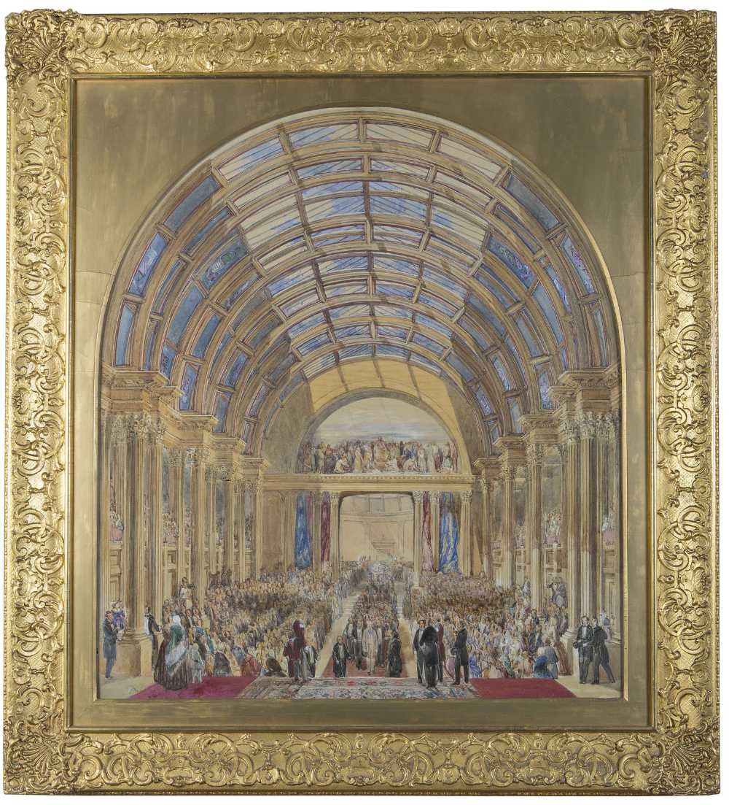
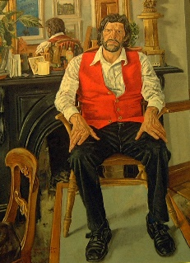
James Mahony, “The Official Opening of ‘The National Exhibition of the Arts, Manufactures and Products of Ireland’ Cork, 1852”.
Friends of Crawford Art Gallery
a support group for the Crawford Art Gallery

Members’ participation in the Friends’ events provides funds to the Friends Legacy Fund for future acquisitions and exhibitions for the gallery.
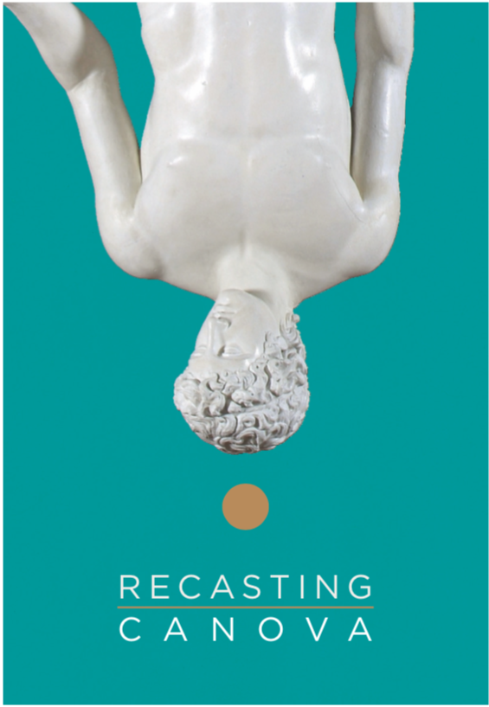
ACQUISITIONS EXAMPLES
1991 * Vivienne Roche: Bronze sculpture
‘Viapori’ Bell commissioned by the Friends 1991
* Joseph Panzetta: Coade stone head of James Barry.
* James Scanlon: Stained glass window, Lonradh The Big Bang

2006 * Mick O’Dea Portrait of Michael O’Siadhail
© Portrait of Michael O’Siadhail by Mick O’Dea

2009 * Print by Michael Farrell Untitled 1983

2013 * Picasso: Maternité print

2014 * Miniature portrait of John Shears attributed to John Comerford (1773 - 1832) Oil on ivory, oval, 8.5cms high.

2016 * Frederick Buck 3 miniatures (watercolour on ivory)
Francis Rowland
Elizabeth Rowland
Francis Rowland when a boy

2017 * The publication of the book ‘Made in Cork’
The Arts and Crafts Movement 1880s -1920s
by Vera Ryan.

2019 * Sponsorship of the Recasting Canova Catalogue
© Crawford Art Gallery

As an independent support group for Crawford Art Gallery, the Friends’ aim is to promote an awareness of the gallery, its collection and exhibitions and to foster an interest in all aspects of art and heritage. Through your membership and participation in the Friends’ events you provide support to the gallery through the Friends Legacy Fund for future acquisitions and exhibitions.

Be a Friend, become a Member

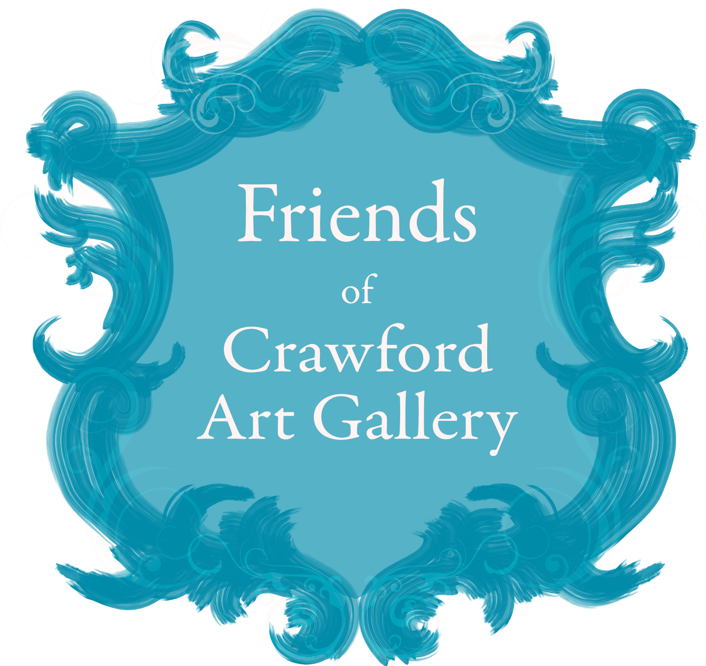
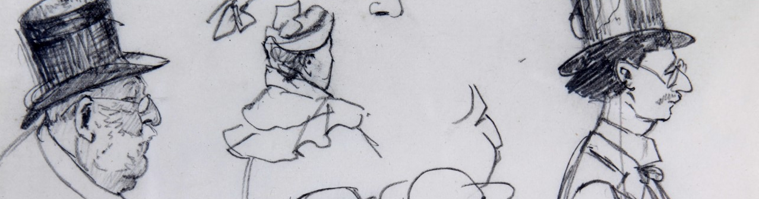
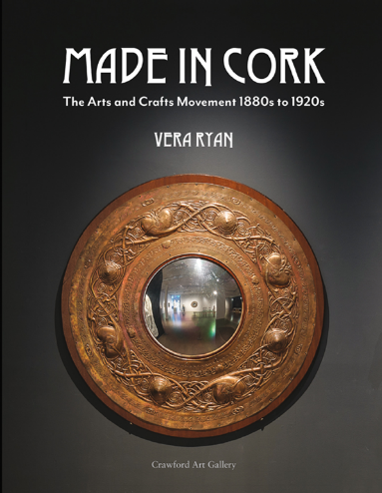
Edith Somerville, Character Sketches (Detail), c.1890. Collection Crawford Art Gallery, Cork.

Friday Nov 26th
Michael Waldron
Edith Somerville: Artist, Writer, Suffragist
Join us as assistant curator Michael Waldron explores Crawford Art Gallery's small but intriguing collection of sketches, witty character studies, and beautifully observed oil paintings by Dr Edith Somerville (1858-1949), one half of the partnership Somerville & Ross, authors of The Irish R.M. stories. Delve into the Parisian studios she attended, the European travels she undertook, and the observations she made closer to home, including The Goose Girl (1888).

James Mahony, “The Official Opening of ‘The National Exhibition of the Arts, Manufactures and Products of Ireland’ Cork, 1852”.
Self-portrait with Saskia, (Detail), 1636 © Ashmolean Museum, University of Oxford
The Gift of Membership
Friends of Crawford Art Gallery Gift Membership is a unique gift packed full of surprises. Choose from our beautiful range of membership options then sit back and let us delight them throughout the year with special Members-only events and generous benefits.

To organise gift membership, first see membership types on the form enclosed and choose the type that suits. Then you can arrange registration in person or post us the form and payment. We will send a gift card with the membership details enclosed on your behalf.

Made in Cork
The Arts and Crafts Movement
1880s to 1920s
by Vera Ryan

Available in the Gallery Gift Shop
This elegant book explores the importance of art and craft made in Cork during the years of the Irish Arts and Crafts movement, the 1880s to the 1920s.

Friends Autumn Lecture Series 2021
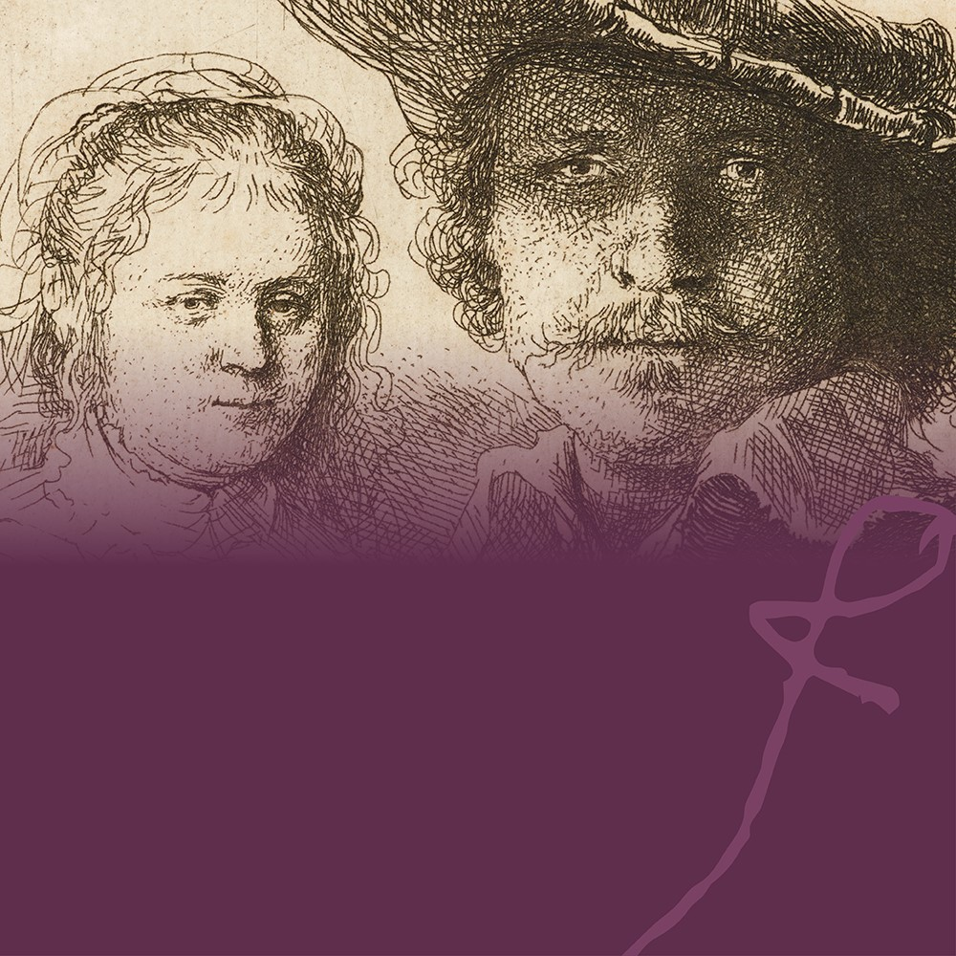
Friday Nov 19th
Matthew Whyte
Rembrandt’s Psychology: Uncovering the Artist’s Insight.
This talk will use a selection of etchings from the exhibition ‘Rembrandt in Print’ to explore the ways in which the Dutch master explored human psychology, emotion, and feeling through a variety of genres. Unlike many of his more monumental paintings, Rembrandt’s etchings afford an opportunity to study the artist’s work in extraordinary proximity, the smaller scale and intense attention to detail inviting the close and personal engagement of his viewers. Rembrandt is known for his ability to portray psychological insight to a degree that set him apart from his contemporaries; his etchings, with their clear sense of line and dramatic chiaroscuro, allow the viewer to examine each individual mark made by the painter before understanding how they come together as a whole. Using his self-portraits, his religious scenes, and his portraits, this talk will seek to convey the extent to which human psychology, whether of his subject or his viewer, captivated Rembrandt and preoccupied his visual language.
Thurs November 25th 6.30-7.30
Kieran McCarthy
Talk on Sir. John Benson
Thursday 25th November 6.30-7.30pm sees up teaming up with the IEI as they celebrate their Cork Regions’ 80th year with this live zoom talk by Kieran McCarthy on Sir. John Benson. This talk resonates well with The Friends as it celebrates our most recent acquisition, a stunning historic watercolour by James Mahoney which depicts a building designed by Benson.
You can view this wonderful painting now which is on display in our Gibson Galleries, a fitting location given its proximity to the buildings' location back in 1855, which is the present-day location of Cork Opera House.

Members’ Calendar of Events

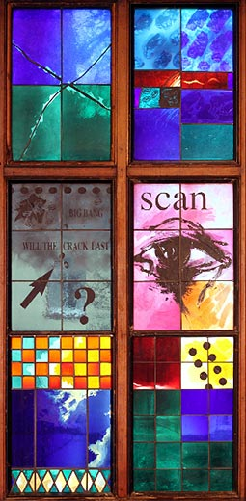

 Friends of the Crawford Art Gallery

 @friendsCAGcork

 friends@crawfordartgallery.ie

Meet the Administrators

You are welcome to visit the administrators at the gallery on
Tuesday, Wednesday and Friday between 10:00 a.m. and 14:00 p.m.
*Please request a meeting with a Friends administrator at the gift shop upon arrival.

Membership forms & Event Brochures are available on our website, via email or at the gallery.

Contact the Friends
Post: Friends’ Office, Crawford Art Gallery,
Emmet Place, Cork, T12 TNE6.
Tel: 0214907864

DATA PROTECTION

Please be reassured that all information supplied is held in confidence; it will not be shared with any third party without your express permission. All personal data will be held in accordance with the GDPR and Data Protection Acts 1988 – 2018. Friends administrators will use this data to send you email & postal (if applicable) information on events, talks, trips and tours provided by the Friends Society and the Crawford Art Gallery.
Email updates are sent via our email provider MAILCHIMP and you can unsubscribe at any time. Your personal information will be retained by the Friends for as long is necessary to administer your membership.
Thank you for supporting The Friends of Crawford Art Gallery.
Honorary Administrators

Annual Subscription
(Hard copy brochures & forms are available on request in the gallery)

Membership options are as follows

Membership / Gift Membership runs from date subscription payment is received and can be renewed annually.

Individual A 12Mths* €60 with Paperless / Email only correspondence
Individual B 12Mths* €65 with email and Postal correspondence

Couples A 12Mths* €90 with Paperless / Email only correspondence
Couples B 12Mths* €95 with email and Postal correspondence

*Please renew membership after 12mths to continue receiving correspondence.
Life membership Annual subscription Fee x 10

Please print & complete the form provided and forward payment.

By Cash / Cheque: (Cheques payable to: Friends of Crawford Art Gallery)

By Post:
Friends’ Office, Crawford Art Gallery, Emmet Place, Cork, Ireland, T12 TNE6

By Standing Order/ Direct Debt: Contact the Friends office for details.

By Bank Transfer: BIC: AIBKIE2D IBAN: IE87 AIBK 9341 4306 8531 11

NB: Due to the new GDPR regulations, if a member chooses not to renew their membership, the Friends administrators will be legally obliged to remove their personal details from the database.
Therefore no postal / email correspondence will be forwarded from the members’ renewal date.

