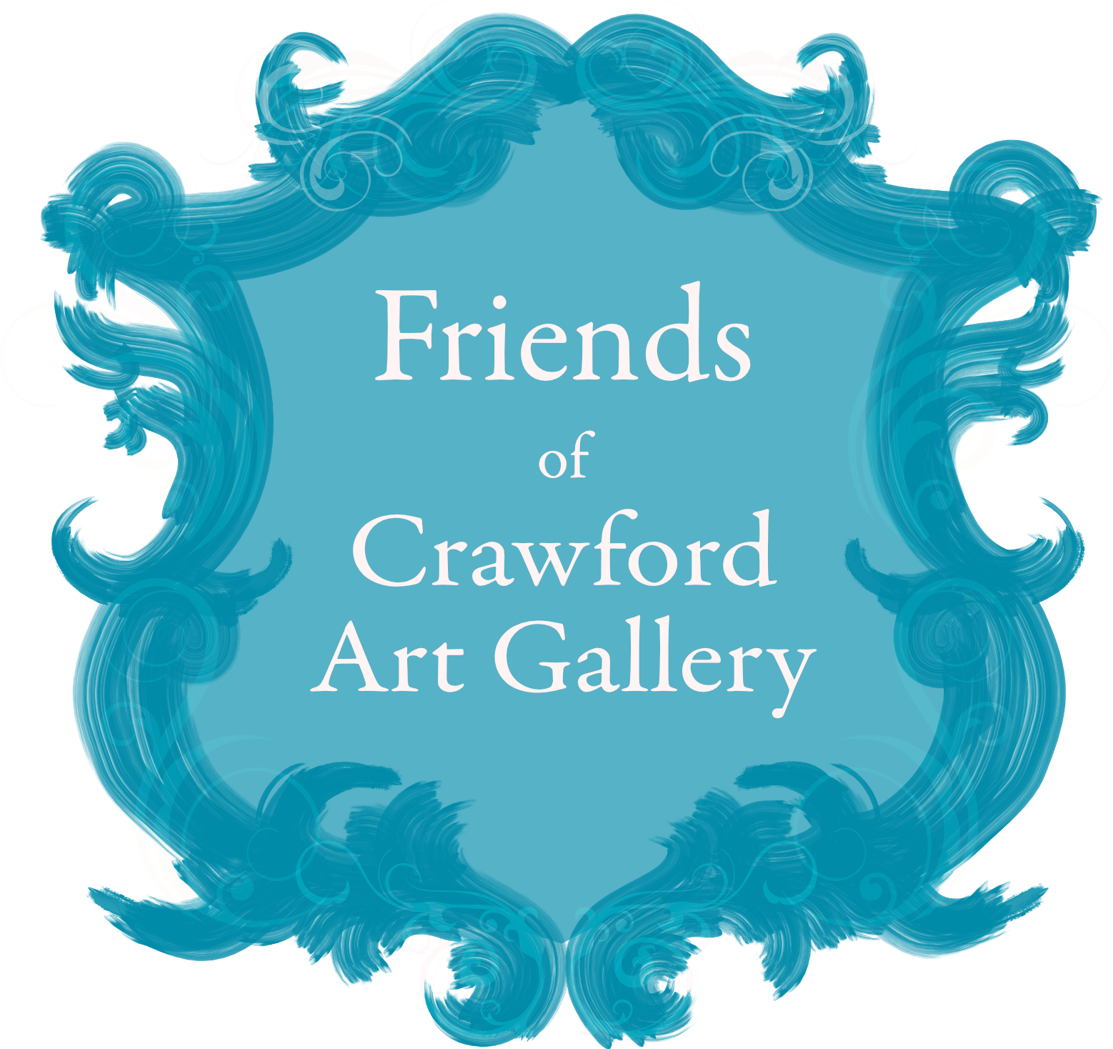



Friends
of the Crawford
Art Gallery

Friends’ Office, Crawford Art Gallery, Emmet Place, Cork, Ireland, T12 TNE6
Tel: 021 4907864 Email: friends@crawfordartgallery.ie

Friends’ Office, Crawford Art Gallery, Emmet Place, Cork, Ireland, T12 TNE6
Tel: 021 4907864 Email: friends@crawfordartgallery.ie

Standing Order Form

To the Manager: ......................................................................................................................................

of (Bank): …………………………………………………………….………………………………….

Address: .....................................................................................................................................................

I/We hereby authorise and request you to debit my/our account

Account number....................................................................................................................................
Account name..........................................................................................................................................

Bank Sort Code.......................................................................................................................................
BIC...............................................................................................................................................................

IBAN...........................................................................................................................................................

with the sum of € .................................... Euro (in words) ................................................................

And to credit the account of: Friends of the Crawford Art Gallery

AIB Bank, 26 Patrick Street, Cork
Account Number 06853111 Sort Code 93 41 43
BIC AIBKIE2D IBAN IE87 AIBK 9341 4306 8531 11

Annually from: ............................................................................ until further notice in writing

Usual Bank Account Signature: ..........................................................................................................

Date: ..............................................

Standing Order Form

(Hard copy brochures & forms are available on request in the gallery)

To the Manager: ......................................................................................................................................

of (Bank): …………………………………………………………….………………………………….

Address: .....................................................................................................................................................

I/We hereby authorise and request you to debit my/our account

Account number....................................................................................................................................
Account name..........................................................................................................................................

Bank Sort Code.......................................................................................................................................
BIC...............................................................................................................................................................

IBAN...........................................................................................................................................................

with the sum of € .................................... Euro (in words) ................................................................

And to credit the account of: Friends of the Crawford Art Gallery

AIB Bank, 26 Patrick Street, Cork
Account Number 06853111 Sort Code 93 41 43
BIC AIBKIE2D IBAN IE87 AIBK 9341 4306 8531 11

Annually from: ............................................................................ until further notice in writing

Usual Bank Account Signature: ..........................................................................................................

Date: ..............................................

